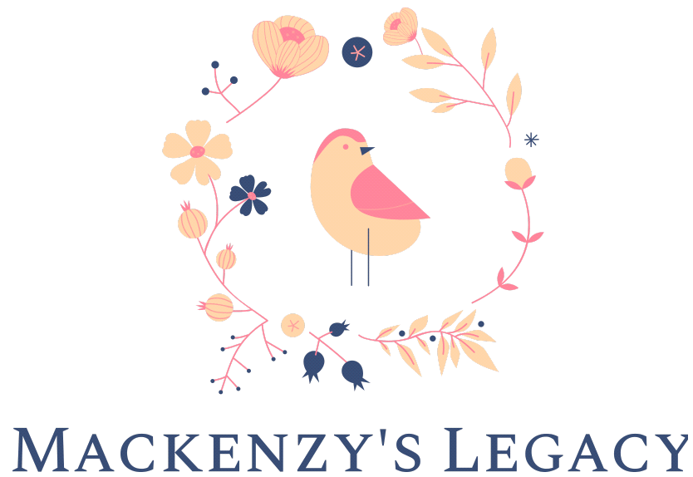
Your Name
123 Your Street
Your City, ST 12345
(123) 456-7890
no_reply@example.com
4th September 20XX
Premier Jason Kenney premier@gov.ab.ca
Honourable Rebecca Schulz cs.minister@gov.ab.ca
Honourable Kaycee Madu ministryofjustice@gov.ab.ca
FILL IN YOUR LOCAL MLA HERE

Dear {contact_data~title} {contact_data~lastName},
I am writing to you today as a concerned constituent. In 2018, 6 years after the tragic death of Mackenzy Woolfsmith, the province undertook a Public Fatality Inquiry. The outcome of that extensive process was a report issued by Justice Hawkes to the Minister of Justice and Solicitor General outlining very detailed recommendations on how to improve the safety and quality of childcare in regulated and unregulated care. To date, these recommendations have not been substantively enacted by the Government, including in the recently amended Early Learning and Child Care Act that was passed by this Government under Bill 39, and the risks to our children that were highlighted by Justice Hawkes remain.
The 2021 Federal Budget was recently released and outlines a desire for a Canada-wide early learning and childcare plan. I support any enhancements to our childcare system in Alberta and would like to see those changes strengthen the safety and quality for families in all forms of childcare, rather than weakening them.
As part of further legislative review, I would like any changes to ensure the following:
- The legislative framework governing the provision of childcare in Alberta should be comprehensively reviewed to address and reduce risk to infants and children in all forms of childcare (licensed and unlicensed).
- A specific focus of that legislative review should be to shift the focus from solely regulating the size of unlicensed daycare to a focus on reducing risk and increasing protective factors in all forms of childcare. Academic research, the experience of other jurisdictions, and the tragedy of Mackenzy’s case all illustrate and support the need for a risk focused regulation of childcare.
- Significant operational and staffing changes must accompany any legislative changes to ensure that timely and effective investigations regarding risk in all child settings. Operational changes include adding the necessary I.T. capacity to track serious incidents and the providers who are involved in such incidents.
- The 2014 report of the Auditor General of Ontario regarding the inspection and review of licensed child care in that jurisdiction revealed that legislative changes, while necessary, is insufficient to create and effective enforcement regime. The objective of that report was to determine if the responsible Ministry had effective management and oversight practices to ensure effective regulation of this sector. The report noted that more than 29,000 “serious occurrences” were reported to the Ministry over a five year period from 2009-2014. The Auditor General made nine specific recommendations relating to enforcement and oversight. Those recommendations should be considered, both in the current legislative framework to ensure that adequate oversight and enforcement actually occurs with licensed facilities and providers in Alberta, and in the context of examining the revised “risk focused” legislative review that has been recommended.
- The new enforcement culture should be a proactive, rather than reactive, complaint driven process. Mechanisms to track ongoing investigations and to audit or review investigations are essential components of such a culture.
- Information sharing regarding critical incidents where significant injury or the risk of significant injury occurs in a licensed or unlicensed day care is essential. Specific investigation and information sharing protocols should be examined regarding critical incidents. In particular, the rights of parents and guardians to information regarding critical incidents should take precedence over the privacy rights or commercial interests of childcare providers or workers regarding essential information in those reports. The Early Learning and Childcare Act, and it’s associated regulations, must be examined and revised where necessary to ensure that information regarding critical incidents can be shared and disclosed appropriately.
- Effective enforcement also requires that the legislation provide for an appropriate range of remedial powers and sanctions, applicable to all forms of childcare providers. These must include the power to immediately close undated daycares, issue remedial orders and monitor compliance, and to restrict or prohibit individuals from providing childcare services.
- Providing child care is demanding work that is often stressful. That stress can be amplified by the number and age of children and is exacerbated when that care is provided in an isolated setting without other adults present for support. Tools for self-assessment, and for support should be readily available and accessible. Mandatory support and assistance should be considered mandatory for all involved in reported critical incidents.
I strongly support increasing safety in all forms of regulated and unregulated childcare in Alberta.
Thank you for considering my concerns as they relate to updates to the child care system (licensed and unlicensed) in Alberta.

Sincerely,
{user_data~First Name} {user_data~Last Name}

CC:
Premier of Alberta
Minister of Children’s Services
Minister of Justice and Solicitor General

